1. 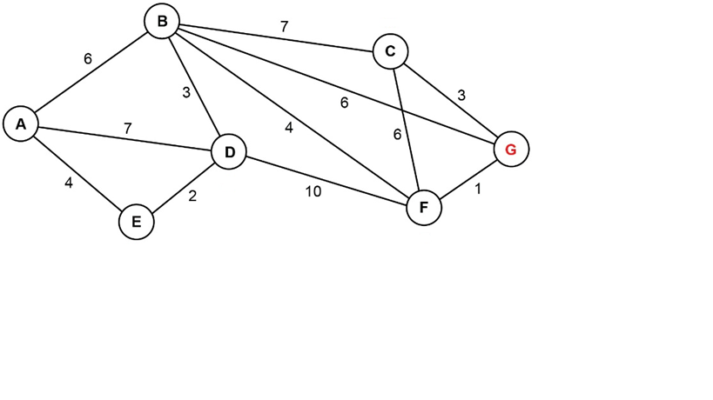

Show the shortest path from A to G (always remember to include the weighting)

|  |  |  |  |
| --- | --- | --- | --- |
| Node | Visited | Cost from start | Previous node |
| A | ✔ | 0 | - |
| B | ✔ | ~~♾~~ 6 | A |
| C |  | ~~♾~~ 13 | B |
| D | ✔ | ~~♾~~ ~~7~~ 6 | ~~A~~ E |
| E | ✔ | ~~♾~~ 4 | A |
| F | ✔ | ♾ 10 | B |
| G | ✔ | ~~♾ 12~~ 11 | ~~B~~ F |

GFBA is A to B to F to G.

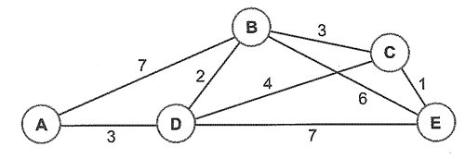

|  |  |  |  |
| --- | --- | --- | --- |
| Node | Visited | Cost from start | Previous node |
| A |  | 0 | - |
| B |  | ∞ |  |
| C |  | ∞ |  |
| D |  | ∞ |  |
| E |  | ∞ |  |

|  |  |  |  |
| --- | --- | --- | --- |
| Node | Visited | Cost from start | Previous node |
| A | ✔ | 0 | - |
| B |  | ~~∞~~ 7 | A |
| C |  | ∞ |  |
| D |  | ~~∞~~ 3 | A |
| E |  | ∞ |  |

|  |  |  |  |
| --- | --- | --- | --- |
| Node | Visited | Cost from start | Previous node |
| A | ✔ | 0 | - |
| B | ✔ | ~~∞~~ ~~7~~ 5 | ~~A~~ D |
| C | ✔ | ∞ 7 | D |
| D | ✔ | ~~∞~~ 3 | A |
| E |  | ~~∞~~ ~~10~~ 8 | ~~D~~ C |

ANSWER SHOWN IN STAGES A -> D -> C -> E costing 8.

1. 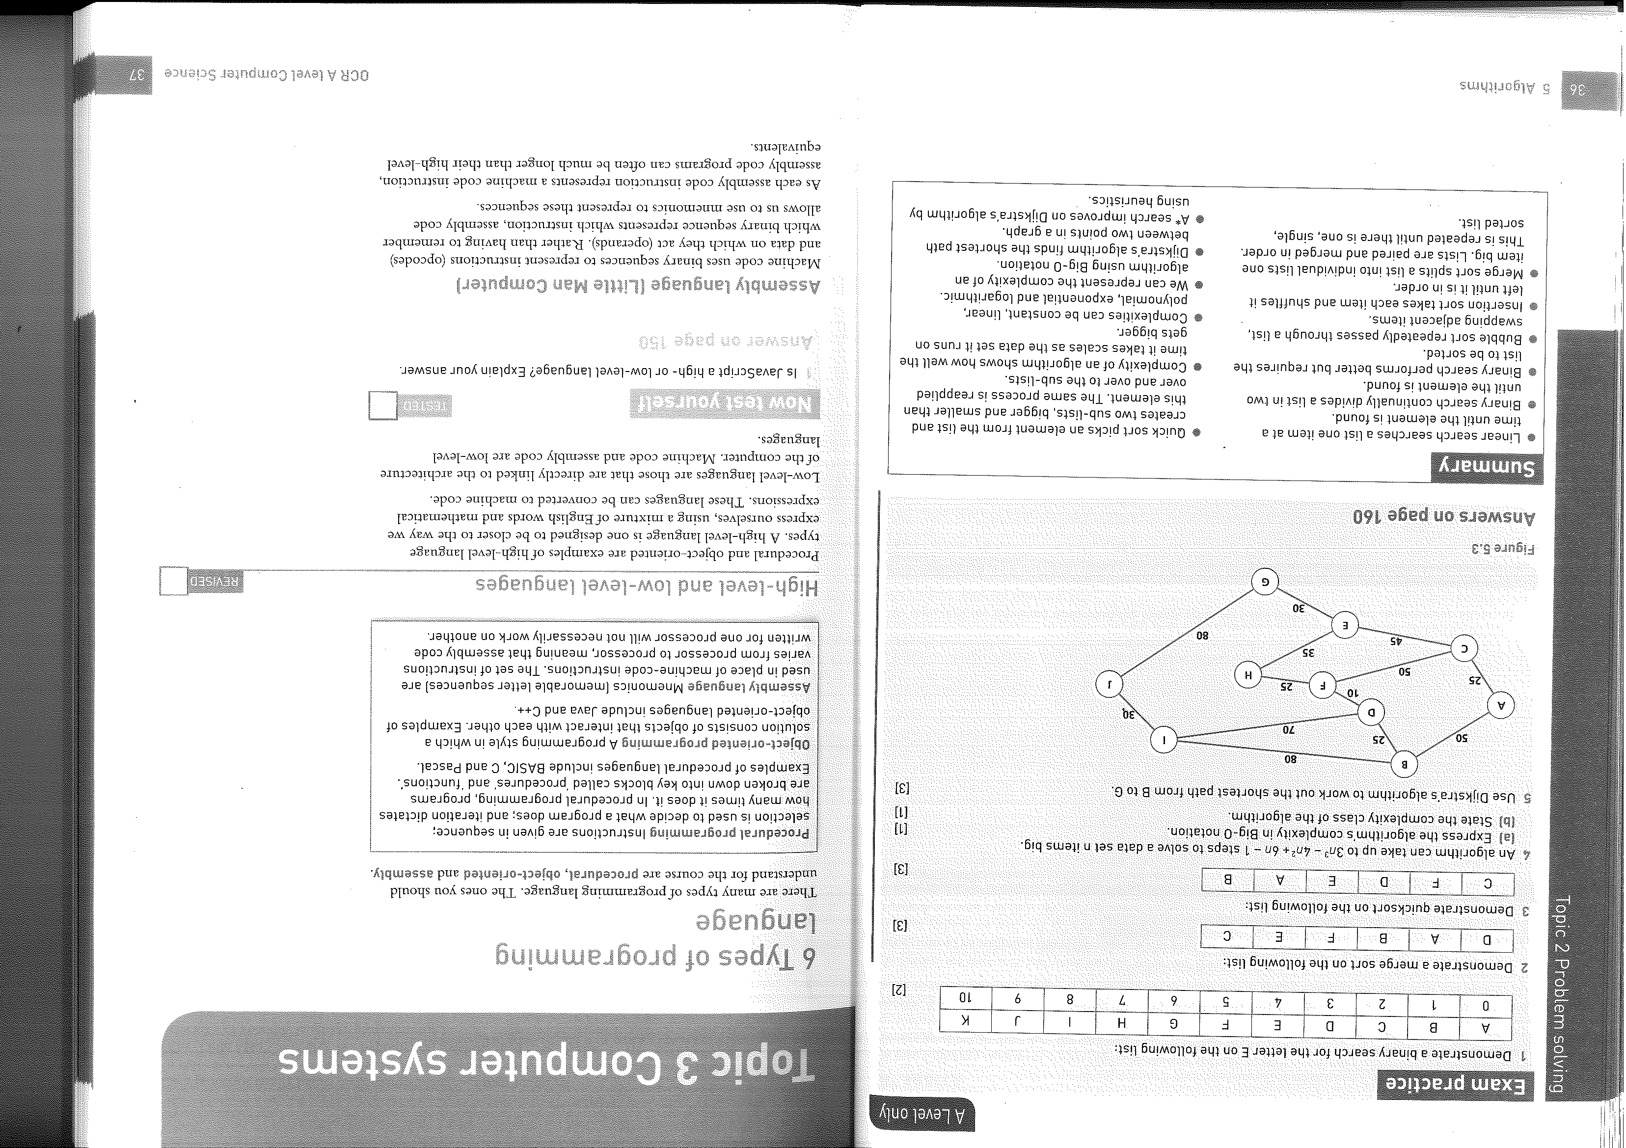

Show the shortest path from A to J including the weighting

|  |  |  |  |
| --- | --- | --- | --- |
| Node | Visited | Cost from start | Previous node |
| A | ✔ | 0 | - |
| B | ✔ | ~~∞~~ 50 | A |
| C | ✔ | ~~∞~~ 25 | A |
| D | ✔ | ~~∞~~ 75 | B |
| E | ✔ | ~~∞~~ 70 | C |
| F | ✔ | ~~∞~~ 75 | C |
| G | ✔ | ~~∞~~ 100 | E |
| H | ✔ | ~~∞~~ ~~105~~ 100 | E F |
| I | ✔ | ~~∞~~ 130 | B |
| J | ✔ | ~~∞~~ ~~180~~ 160 | ~~G~~ I |

A to B to I to J costs 160.

B

E

C

F

A

G

D

4

3

5

7

1

2

5

7

3

2

4

Using this graph, trace Dijkstra’s algorithm to show the shortest path between A and G including the weighting.

|  |  |  |  |
| --- | --- | --- | --- |
| Node | Visited | Cost from start | Previous node |
| A | ✔ | 0 | - |
| B | ✔ | ~~∞~~ 4 | A |
| C | ✔ | ~~∞~~ 2 | A |
| D | ✔ | ~~∞~~ 5 | C |
| E | ✔ | ~~∞ 8~~ 6 | ~~B~~ D |
| F | ✔ | ~~∞~~ 7 | D |
| G | ✔ | ~~∞ 13~~ 12 | ~~E~~ F |

Shortest path is A,C,D,F,G at 12

12

7

9

5

8

2

|  |  |  |  |
| --- | --- | --- | --- |
| Node | Visited | Cost from start | Previous node |
| A | ✔ | 0 | - |
| B | ✔ | ~~∞ 12~~ 10 | ~~A~~ B |
| C | ✔ | ~~∞~~ 17 | B |
| D | ✔ | ~~∞~~ 2 | A |
| E | ✔ | ~~∞~~ 11 | D |

Path is A to D to E at 11.

**A* Algorithm Questions**



|  |  |  |  |  |
| --- | --- | --- | --- | --- |
| Node | Est total cost  (F = G + H) | Cost so far (G) | Heuristic cost (H) | Previous node |
| A | 80 | 0 | 80 |  |
| B |  |  | 90 |  |
| C |  |  | 70 |  |
| D |  |  | 50 |  |
| E |  |  | 20 |  |
| F |  |  | 0 |  |

|  |  |  |  |  |
| --- | --- | --- | --- | --- |
| Node | Est total cost  (F = G + H) | Cost so far (G) | Heuristic cost (H) | Previous node |
| A ✔ | 80 | 0 | 80 | - |
| B ✔ | 300 | 210 | 90 | A |
| C ✔ | 95 | 25 | 70 | A |
| D ✔ | 126 | 76 | 50 | C |
| E ✔ | 221 | 201 | 20 | C |
| F | 383 | 383 | 0 | D |

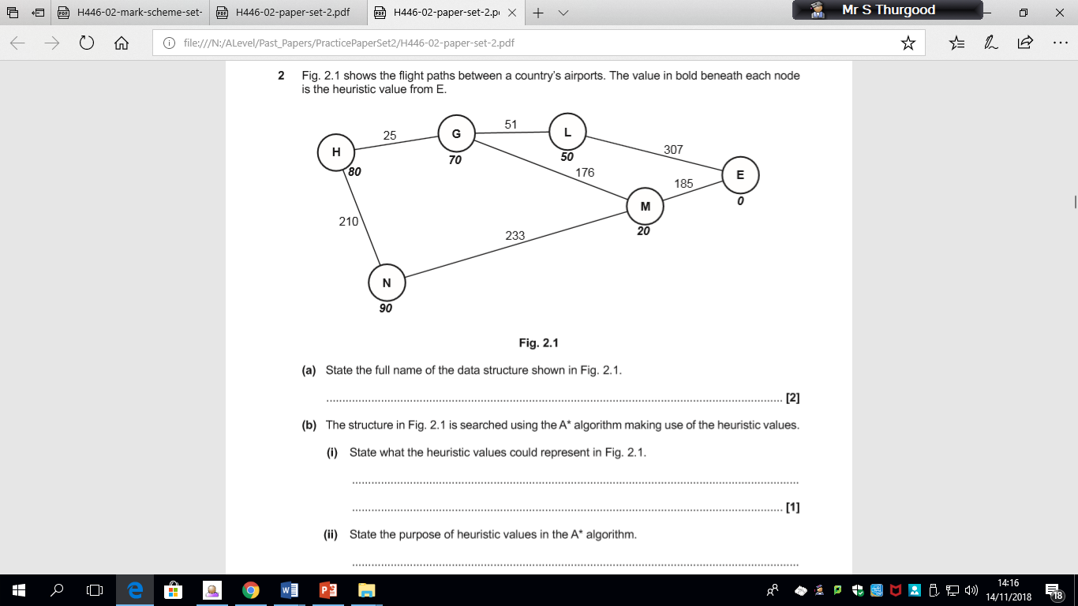

Perform an A* algorithm on the data structure in Fig. 2.1 to find the shortest distance between H and E. Show each step of the process, and the calculations performed for each node visited.

|  |  |  |  |  |
| --- | --- | --- | --- | --- |
| Node | Est total cost  (F = G + H) | Cost so far (G) | Heuristic cost (H) | Previous node |
| H ✔ | 80 | 0 | 80 | - |
| N ✔ | 300 | 210 | 90 | H |
| G ✔ | 95 | 25 | 70 | H |
| L ✔ | 126 | 76 | 50 | G |
| M ✔ | 221 | 201 | 20 | G |
| E | 383 | 383 | 0 | L |

H to G to L to E is 383.

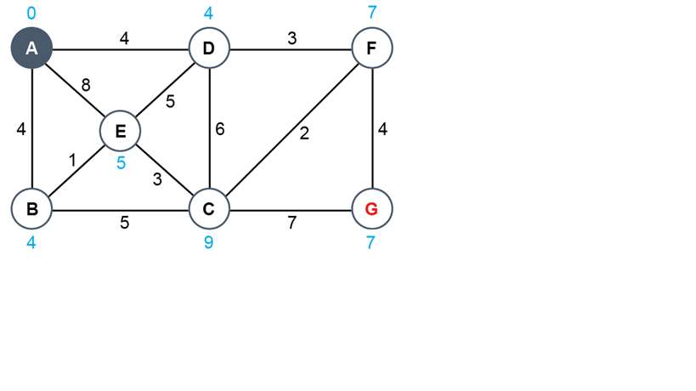

Perform the A* algorithm on the above graph starting from Node G.

|  |  |  |  |  |
| --- | --- | --- | --- | --- |
| **Node** | **Est total cost  (F = G + H)** | **Cost so far (G)** | **Heuristic cost (H)** | **Previous node** |
| A | 11 | 11 | 0 | D |
| B |  |  | 4 |  |
| C | ~~18~~ 15 | ~~9~~  6 | 9 | ~~G~~ F |
| D✔ | 11 | 7 | 4 | F |
| E |  | 12 | 5 | D |
| F✔ | 11 | 4 | 7 | G |
| G✔ | 7 | 0 | 7 | - |

G to F to D to A costs 11.